# PlannedEP

Process flow: <https://lucid.app/lucidchart/3654dd53-de39-4763-96df-63a5da5826c2/edit?invitationId=inv_4f1a41d3-fd4b-48c7-a269-00330d96f808>

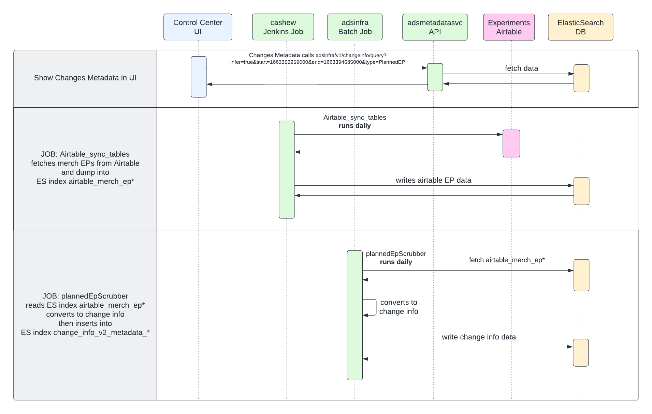

Architecture Diagram: